Happy New Year! I hope this year brings you happiness and lots of opportunity to fly.

Sitting here on Sunday afternoon watching it pour down rain (and the Seahawks play) again, It seems like that wish may not happen, but it will eventually. I wanted to take the time to send a note to all my clients actively trying to fly to let you know all is not lost. This typically happens this time of year. In many years we get a high-pressure ridge that moves in in late January that provides good flying opportunities. If you are on the addressee list, I haven’t forgotten or given up on providing you the very best in flight training.

Lots of questions on the schedule of my availability. This time of year, I am available any time the weather will allow training. I don’t keep specific hours. Having said that I am looking at the week of January 9-13 and not seeing any good weather days. What I don’t want to do is sit around the airport trying to get a lesson off when the weather is 50/50. So, if I spoke to you about possibly flying this week, I really don’t see a good opportunity. I realize you all have schedules as well, and it is hard to call you up an hour before an opportunity appears, but if you let me know you could possibly fly on short notice I’ll keep an eye out for a last minute opportunity.

The weather hasn’t allowed flying for the past two months. I think I have logged maybe three hours in the that time to stay current, flying very last minute when I saw a sun break. Besides enjoying family over the holidays, I have been staying busy writing. One of my articles was recently published in the Washington Pilot’s Association Publication Wings. You can find an online link to the article here: https://rogersaviationnw.com/articles--publications.html
AOPA has asked to publish my entire series of articles on the traffic pattern. Not sure when that will happen.

I also found time to create and publish my website: rogersaviationnw.com stop by and take a look if you haven’t already. Hopefully if all goes as planned, I will publish more videos and articles relating to your training there.

I have also been asked to present again at the Northwest Aviation and Trade show at the Puyallup fair grounds on February 25-26, 2023. You can find the shows website here: https://www.washingtonaviation.org/conference I will present a version of my Non-Towered traffic pattern operations presentation.

OK that is it for today. No flying the Week of January 9-13 and I’ll look for opportunities as they arise. I’ll let you know about the week of 16th toward the end of this week coming up.
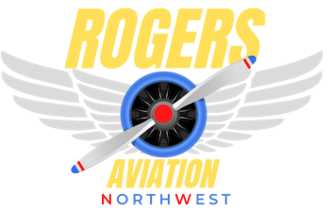
Best regards.
Tom Rogers

